How to Setup or Refresh CUI DEV Environment

Revision History

|  |  |  |
| --- | --- | --- |
| Date | Author | Content |
| 09/10/2014 | Rae Andrews | Initial version. |
| 09/22/2014 | Rae Andrews | Adding ActiveNetSites db info |
| 11/11/2014 | Bridget O’Flaherty | Add some notes for clarification |
| 9/8/2016 | David Christie | Some corrections |

Setup CUI in DEV Environment

1. **Create IronPointCM database**

Open the script “\ACM\ACMRoot\DatabaseScripts\IronPoint.Install.SQL2012.sql” in SQL Server Enterprise manager.

Find the “CREATE DATABASE” statement near the top of the script, and change the paths if necessary for where the MDF and LDF files should be created.

Find the two sp_addlogin calls (one for adding “CM” and one for adding “mcw”). If necessary change both to a password that will not fail your password policy. *[I set my password to “safari” for both.]*

Run the script. It should complete with no errors. If not, then delete the database, fix the problems, and run the script again.

*[Now that you have a freshly created database, do a backup of it. This will simplify things later on when you want to refresh your CUI environment.]*

1. **Configure Connection string \ACM\ACMRoot\bin\IronPoint.DataAccess.dll.config**

Copy the “IronPoint.DataAccess.dll.config” file from the “ACM\Templates” folder into the “\ACM\ACMRoot\bin” folder.

Edit the config file, find the “dataSource” where name=”SQL”, and set the password to be what you specified for the “mcw” login in #1 above (or whatever user is specified for “User ID).

[BOF] Also set actual IP_DB_SERVER (e.g. 127.0.0.1) and IP_DB_NAME (e.g. IronPointCM) values.

1. **Compile the CUI project**

Open the Visual Studio 2010 project solution “\ACM\ACMRoot\ActiveNet.sln”, and select Build / Rebuild Solution from the top menu.

1. **Create new CUI web site in IIS**

First, create a new Application Pool called ACM to use for the new site, pointing to .NET Framework version 4.0.x and set to Classic pipeline mode.

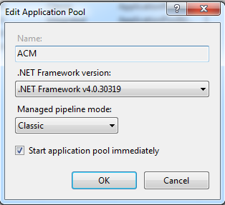

Next, create a new site called ACM, select the ACM application pool created above, point it to the physical location of the “ACM\ACMRoot” source code folder, and specify the host name “apm.activenet.com”.

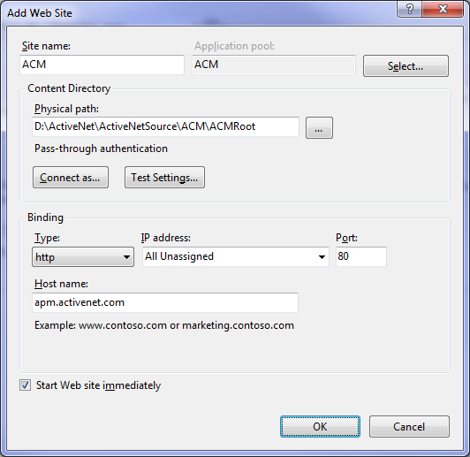

Go into the URL Rewrite rules and disable both rules “Redirect to https” and “Rewrite orgname to right”. In ACM\ACMRoot\Web.config the rewrite rules can be commented out. You will need to do to avoid IIS error on Web.config (HTTP Error 500.19 0x8007000d).

In IIS configuration for the ACM site, make sure ISAPI filters are set up for both 32 and 64 bit.

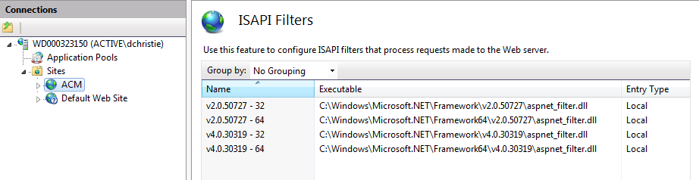

At the server level, make sure the aspnet_isapi.dll’s are all allowed:

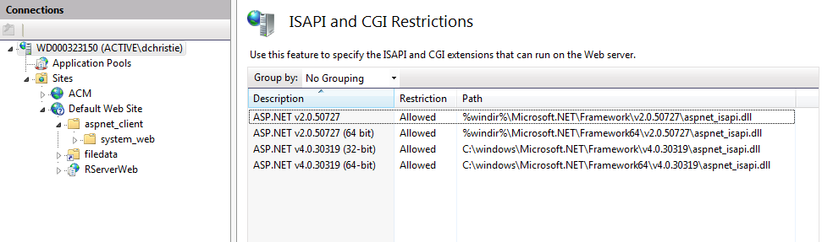

1. **Set up hosts file entry for new web site**

Edit your “C:\Windows\System32\drivers\etc\hosts” file (if using Notepad you will have to open as administrator to have permissions to save the modified file), and add mapping for the apm.activenet.com host name.

127.0.0.1 apm.activenet.com

1. **Test access to new CUI web suite**

Open a browser and enter the URL <http://apm.activenet.com/Site3.aspx> .

You should see a page like this:

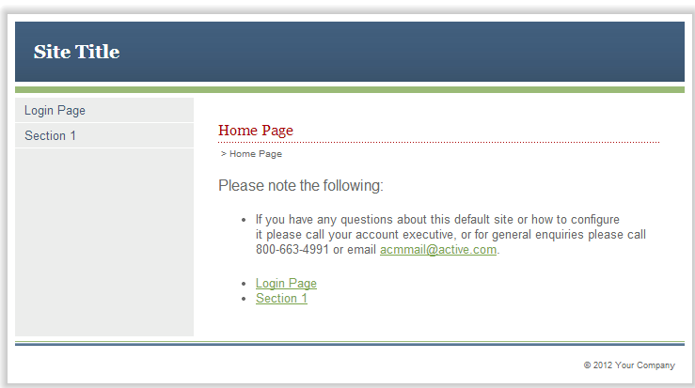

1. **Run deployer to install ActiveNet CUI**

Run the utility “\ACM\Deployer\Deployer.exe”, and set the values as below (see the ReadMe.txt file).

This will install a new site (id = 4) in ACM for ActiveNet CUI. Note that these values are for when you are running ActiveNet locally in DEV mode (so accessing ActiveNet would be done via the URL <http://localhost:8080/ActiveNetServlet/adminLogin.sdi>).

Once ACM is deployed and the servlet is running, should be able to go to new site (e.g. site4): http://apm.activenet.com/site4.asp

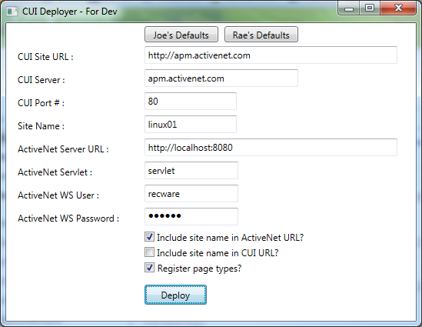

For MT config, the site name should be the name of the ActiveNet site (the database name).

1. **Configure ActiveNet for local CUI**

In SQL Server Enterprise Manager run the following queries against your local ActiveNet database to configure its system options for running local CUI.

This is especially important if restoring a customer database to run locally.

update systeminfo set KEYWORDVALUE = 'apm.activenet.com' where KEYWORD = 'cui_url';

update systeminfo set KEYWORDVALUE = 'false' where KEYWORD = 'require_cookies';

update systeminfo set KEYWORDVALUE = 'false' where KEYWORD = 'use_akamai';

update systeminfo set KEYWORDVALUE = 'false' where KEYWORD = 'use_akamai_cui';

update systeminfo set KEYWORDVALUE = 'false' where KEYWORD = 'secure_public_pages';

update systeminfo set KEYWORDVALUE = 'false' where KEYWORD = 'secure_private_pages';

--Insert systeminfo values that didn’t previously exist

insert into SYSTEMINFO (KEYWORD, KEYWORDVALUE)

select 'cui_url', 'apm.activenet.com' where not exists (select 1 from SYSTEMINFO where keyword = 'cui_url');

insert into SYSTEMINFO (KEYWORD, KEYWORDVALUE)

select 'use_akamai', 'false' where not exists (select 1 from SYSTEMINFO where keyword = 'use_akamai');

insert into SYSTEMINFO (KEYWORD, KEYWORDVALUE)

select 'use_akamai_cui', 'false' where not exists (select 1 from SYSTEMINFO where keyword = 'use_akamai_cui');

1. **Configure ActiveNetSites DB for local CUI**

In SQL Server Enterprise Manager run the following queries against your local ActiveNetSites database to add sites and carriers so that they show up in the applicable lists in CUI.

In each folder there is an **insert.sql.txt** file that contains the query to run. Each query will need to be updated to add the correct path for the applicable CSV file.

<https://fndsvn.dev.activenetwork.com/ActiveNet/trunk/Utilities/Carrier>

<https://fndsvn.dev.activenetwork.com/ActiveNet/trunk/Utilities/Countries>

1. **Run the servlet.**

Once the servlet is running, you should then be able to go to the CUI: <http://apm.activenet.com/site4.aspx> (e.g. site 4 which was deployed above).

You may need to make sure AUI Web Admin > Active Staff > “Redirect legacy CUI requests to new CUI” option is enabled.

Refresh CUI in DEV Environment

Periodically you will need to refresh your CUI site in order to test your feature changes (if your changes involved changes to the ACM-SITE-MAP.xml or Template.zip files), or to obtain feature changes done by other developers.

These steps will bring your CUI environment in line with what a customer site would be following an automated deployment.

1. **Revert or remove modified files**

Using a subversion client tool like Tortoise, choose to revert changes in the ACM\ACMRoot folder.

When the Revert dialog is displayed, click on the “Delete unversioned items…” button at the bottom left, which will open a new dialog listing all files that do not exist in subversion. Find and uncheck “bin/IronPoint.DataAccess.dll.config”, and click on OK to delete all other files listed.

In the Revert dialog usually only two files will show up in the list, Web.config and Sites/4/Admin/default.aspx. You will only want to revert the aspx file, do not revert Web.config.

1. **Compile the CUI project**

Open the Visual Studio 2010 project solution “\ACM\ACMRoot\ActiveNet.sln”, and select Build / Rebuild Solution from the top menu.

1. **Recreate IronPointCM database**

If in step #1 in the setup instructions above you did a database backup of your IronPointCM database, you can now just restore from that backup with the “Overwrite the existing database” option.

If you did not do a backup, you will have to delete your database and create it again using the same instructions in step #1.

1. **Run deployer to install ActiveNet CUI**

As per step #7 above, run the utility “\ACM\Deployer\Deployer.exe”, and set the values as specified in the ReadMe.txt file.